APIs Details based on Functionalities
- Pricing Details API:
- Inventory Details API:
- Restriction Details API:
- Rationing Details API:
- Cart Details API:
- Checkout Details API:
- Order Submission Details API:
- Order History Details API: # to be updated
- Order Confirmation Details API: # to be updated
- LOGIN API:
- JWT/OAUTH API:
- SEARCH API:
- User Lookup API:
- User Setup API:
- Locations API:
- Locations API:
- User locations API:

Pricing Details API:
API Name:
web-product-pricing-v1-eapi
Resource name: /product/pricing/linelevel
Method : POST
Dev URL:
API Involved:
- web-product-pricing-v1-eapi
- product-pricing-papi
- webmethod-product-pricing-proxy
Design Diagram with scenarios and including source and target system:
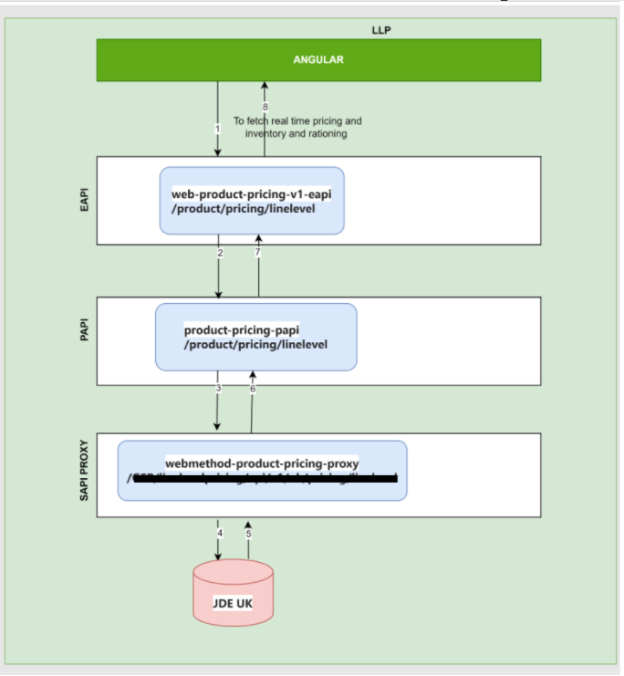
Design Link (Confluence):

Postman collection attached:

Inventory Details API:
API Name:
web-product-pricing-v1-eapi
Resource name: /product/pricing/linelevel
Method : POST
API Involved:
- web-product-pricing-v1-eapi
- product-pricing-papi
- webmethod-product-pricing-proxy
Design Diagram with scenarios and including source and target system:
Design Link (Confluence):
Postman collection attached:

